My SwimRun Friendship Battle 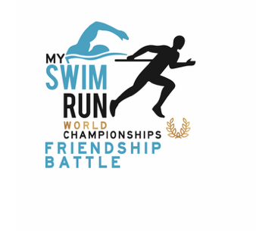
First Weekend Results Are Now Official!
It was a fantastic start! Despite the cold water temperatures in the north, a total of 1,717.5 km were completed on the first weekend. That means an average of 17 km per active participant.
In the team ranking, "The Turbo Tadpoles – die Kraulquappen" from Germany took the lead with an average of 27.6 km, followed by the Floating Rockets (also from Germany) with 22 km, and Team Frostbite from Sweden with 20.2 km. All three teams already took part last year. The first new team is Team Sumin from Poland, who did very well with 19.1 km.
In the men's individual ranking, last year’s winner started strong again and took the lead with 56.5 km, just ahead of Marcel Sandow with 46.5 km. In third place (currently tied) are Grzegorz Oller, Mateusz Czaja (both from Poland), and Sebastian Colberg, all with 43.5 km.
In the women's ranking, Iwona Basara (Poland) is in first place with 43 km, just ahead of Joanna Kaszubowska (PL) and Anika Gerlach (GE), who both have 42 km.
In the country ranking, Germany is currently ahead of Sweden and Poland.
The first challenge to score from each team member on Saturday and Sunday closest came Team The Turbo Tadpoles- die Kraulquappen, with a share of 50 % of the team members.
There is still a long way to go until the end, but this was a strong first sign. Let´s see how the teams can score during the week. The ranking page is getting a lot of attention, and that will motivate the teams even more.
We are especially happy about all the activity on social media. Let’s have fun and spread the message of SwimRun to your networks!
All the best going forward!
Next challenge: The Coolest Team Picture May 26^{thMay} -1st june , 2025
Team leads or members can submit pictures on soc. media with @myswimrunchampionships and #myswimrunchampionships until May 19, 24:00
The picture with the most likes wins
Voting ends the following Wednesday at 12:00 PM
Award: Caps from MySwimrun Championships, Buy 1 get 2 for Pogosta Swimrun Camp, Finland (value 599€, including free slot to Backyard Swimrun

