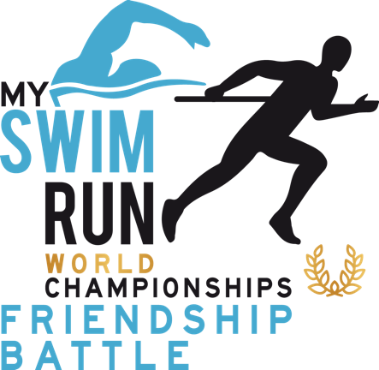
To athletes
Welcome to the SwimRun Battle of Nations 2025!
Objective:
In preparation for the SwimRun Season 2025, we aim to create additional incentives, motivate athletes to start training early, gain more motivation, involve new SwimRunners, and generate a broad impact in the social media scene for our sport within the respective community.
Motivation:
- Self-motivation is key to getting into a sports rhythm.
- Additional dynamism should be achieved in local hot spots, training groups, and clubs.
Date: one Month - 24th of May – 22nd of June
Systems/registration:
- Registration link via Race ID: will follow
  - Registration fee is 11 Euro
  - Registration starts from 1st of April
- Processing and Evaluation: Participants upload their data using the registration mail of the RaceID system.. Link to data upload form
https://docs.google.com/forms/d/e/1FAIpQLScoXn9ec79SeJnmtgjJCOiNX1DVeG3KfSs1UYrZXOUeu0gB7w/viewform
Rules:
- A Team consists of 5- 10 participants
- A SwimRun consists of a total distance of at least 2 km, with 2 swimming and running sessions each and should aim for at least 5% - recommended 10 % of swimming
- Any number of sessions can be completed per day.
- SwimRun uploads must be done by midnight of the following day; (internally 48 h), later uploads will be immediately deleted.
- Single SwimRunners or teams with less than 5 athletes can join an international team
- Emphasis on motivation and fun over dishonesty.
- Trust is emphasized, with motivation and fun in favour of over excessive ambition
(Note: A GPS watch is necessary; if unavailable, please coordinate with your team leader)

Points/Evaluation/Ranking:
  - Person: Total km
  - Teams: Average km of team members
  - Nations: points (correlation average of team members and performance km
Prizes/Goodies:
- Each participant is entered into a draw for three starting places at our Qualifier races
- Additional prizes from sponsors are raffled among participants who upload their contributions on social media and tag with @myswimrunchampionships or our specific challenges
Communication:
- Weekly communication of results: Results Page
- Ongoing communication on the website and social media platforms of @myswimrunchampionships and various pages and groups.
Contribution Fee: 11 Euro
Partners: Wolff Wear, Kreuz&Quer - SwimRun e.V., Race ID, Herbalife Partner, Mako, LaufSinn
Organizer: My SwimRun Championships
Coordinators: Andreas Sachs (A) and Michael Gerlach (D)

Wishing you success and a lot of fun!

Andreas & Michael

