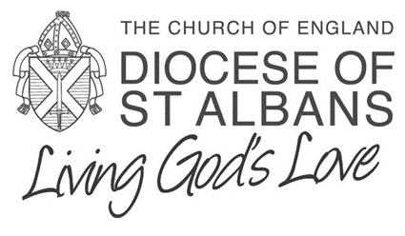

“What Language Should We Use?”

A guide for parishes writing Parish Profiles and Patrons and Archdeacons preparing advertisements

Prepared by Revd Lucy Davis

February 2016

This leaflet lays out words and phrases which have been shown to help to attract the widest possible range of applicants for clergy posts. Research shows that the choice of language in advertisements and role specifications has a strong influence on the number and variety of candidates attracted to a post. We therefore encourage Patrons and Archdeacons with responsibility for writing the advertisement and Parishes with responsibility for writing person specifications and parish profiles to use language of the style described.

On the reverse of this leaflet you will find two examples of person specifications for an imaginary Parish, illustrating two possible uses of language. The qualities sought in the person specifications are the same; they are simply expressed in different ways.

* Version A uses language that will restrict the range and number of applicants for a post.
* Version B uses a style of language shown by research to attract a greater breadth and number of applicants.

We hope the examples here will give a feel for the best language for advertisements and Parish Profiles.

**Research shows that using the following words encourage a greater number of variety and applicants to posts:**

Affectionate

Cheerful

Collaborate

Committed

Communal

Communicate

Compassionate

Connect

Conscientious

Co-operate

Dedicated

Dependable

Emotional

Empathy

Honest

Interpersonal

Interdependent

Kind

Loyal

Nurture

Responsible

Sensitive

Sociable

Support

Together

Trust

Understand

Warm

**The following phrases from advertisements for clergy appointments illustrate how this style of language might be used:**

* Enable creative thinking about….
* Support and encourage the church family in change….
* Nurture the church community as it grows in depth and breadth…
* Committed, collaborative team…
* Develop networks of relationships in the local community…
* Highly emotionally intelligent…
* Empathize with young people…
* Connect more fully with…
* Preaches with sensitivity and understanding…
* Bring people together to engage with…
* A skilled and sensitive communicator experienced at juggling complex demands…
* Desire and skills to draw people…
* Share our commitment to…
* Committed and compassionate priest…
* Person of grace and passion…
* Motivator of people…
* Community minded….
* Release the gifts of …
* Offer experience of..
* Church which serves…
* Share God’s love in the community…
* Nurture individuals in their own ministry…
* Flexible approach to worship….
* Explore imaginative approaches to….
* Long for a loving and hospitable church

**The Bishop of St Albans wishes to appoint a**

**Vicar**

**for**

**St Anthony, Harpersham**

**(A)**

We are looking to appoint an able and visionary priest who will

1. Have a high profile locally, being visible, active and engaged in the town.
2. Manage the Parish through a process of change and lead a review of our Mission Action Plan.
3. Build up lay ministry and form teams.
4. Be a competent, confident preacher, teaching theology and the Bible in a challenging manner.
5. Lead the Church into numerical and spiritual growth.
6. Be robust, pastoral and have a good sense of humour.

**(B)**

We are looking to appoint a committed and compassionate priest who will

1. Be community minded and develop networks of relationships locally.
2. Support the church community through change and enable creative thinking about our Mission Action Plan.
3. Nurture individuals in their own ministry and encourage collaborative working.
4. Preach with sensitivity and understanding, communicating the Gospel in an inclusive and engaging style.
5. Enable the Church community as we grow in depth and breadth.
6. Be resilient, caring and sociable.