Professional Catering Services
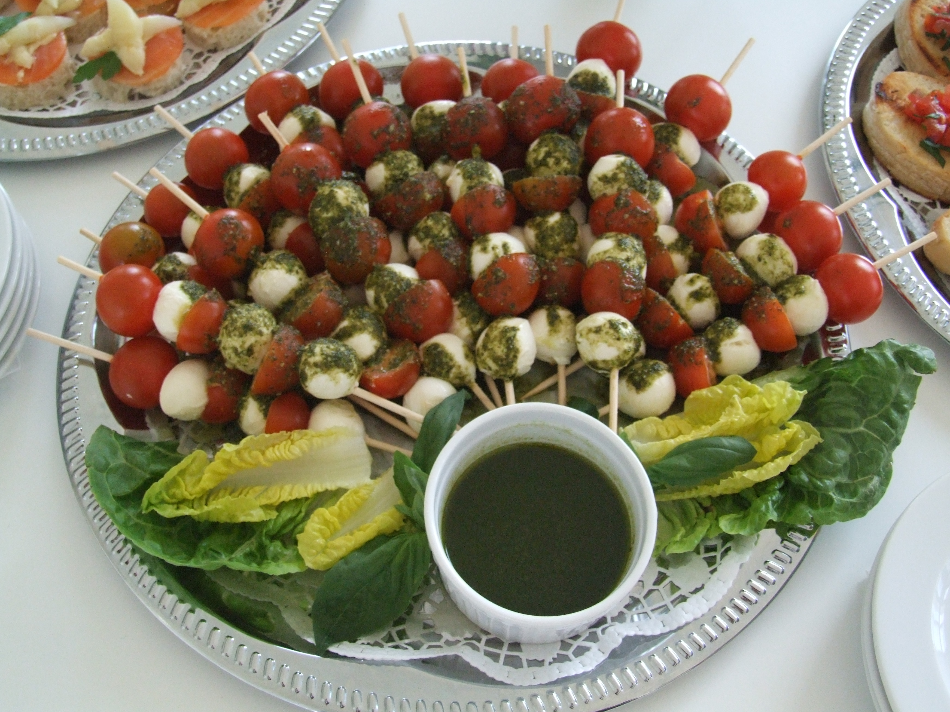

-p.P. Price for selection of 6 items from your favorite buffet choice!!!
(prices subject to error or change)
Summer 2020

Fingerfood or Flying buffet

Romaine salad boats
Canape´s
Cheese sticks
Fruit sticks
Party Bouletten
Spicy Chicken Tenders
Shrimp Provencial
Bruschetta
Steak sticks
Vegetable cups
Caesar salad in glass
Petit fours (30 pieces)
Fruits cups

( p.P. 18,95 € / min. 10 Persons)

Fish Specialties

Smoked Salmon
Smoked Trout
Smoked Eel
Shrimp Provencial
Fried Shrimp Tempura
Spicy Shrimp Dip
Shrimp Gumbo
Shrimp Jambalaya
Shrimp Cocktail
Oysters on the half-shell
Oysters Rockefeller
Oysters Casanova
Fried Calamari with Aioli
Clam Chowder
Octopus salad
boiled Crawfish

( p.P. 42,95 € / min. 10 Persons)

American buffet

Spare ribs with barbecue sauce
Grilled Chicken
Hot Dogs
Hamburgers
Tri-tip Roastbeef
Roast Beef Sandwich
Pastrami Sandwich
Chicken Wings
Mini Steaks with herb butter
Corn on the cob
Coleslaw
Day pickles
Taco salad
Caesar salad
Apple pie
Fruit cups

( p.P. 34,95 € / min. 10 Persons)

Italienisches buffet

Ham platter
div. Anti-pasto
Caesar salad with Croutons
Gourmet Pizza
Beef Lasagne
Vegetarian Lasagne
Grilled Vegetables with Pesto
Crawfish Ravioli
Canneloni
Pasta with Vegetables
Ruccola, Tomato & Basamico Salad
Mozzarella & Tomaten Caprese
Fried Calamari
Garlic Bread
Tiramisu
Fruit with Marscapone

( p.P. 29,95 € / min. 10 Persons)

Deutsche buffet

Pork Roast with Sauerkraut
sautéed Beef Liver with Apples
Pork sausages with Bread roll
German meatballs
Pan Fried Trout
Potato & Leek soup
Lentil soup
Chicken & Vegetable Soup
stuffed Cabbage
spicy pork Schnitzel
Sausage & Ham platter
Emmentaler cheese platter
Harzer cheese with Onion
Potato salad with green onion
pickeled red Cabbage salad
Berries with vanilla sauce

( p.P.32,95 € / min. 10 Persons)

Spanish buffet

Serrano Ham platter
Calamari salad
garlic Gambas with Aioli
stuffed Shrimp balls
pan fried Fish filet
Vinegar marinated Anchoives
Potatos brava with sauce
Dates & bacon rolls
fried Sardines with lemon
Fish, Pork & Shrimp Paella
Bread with Tomato & Garlic
Pickeled Vegetable salad
Spanish Tortilla
Bean & Rice salad
Spanish cheese platter with fruit
Caramelized Custard

( p.P.32,95 € / min. 10 Persons)

Mexican buffet

Tortilla chips
Salsa & Guacamole Dips
black Bean salad or Dip
Spiced Ground Beef
mixed Bell Pepper & Onion sauté
Beef Fajitas
Chicken Fajitas
Taco Salad
Burritos
Ensalada
Fish filet
Shrimp & Cheese Dip
Enchiladas
Stuffed Tomales
Seasoned Rice
Fruit salad

( p.P.34,95 € / min. 10 Persons)

BBQ buffet

Tri-tip Roast Beef
Top Sirloin Steaks
Ribeye Steaks
Hot dogs
Hamburgers
grilled Chicken
Corn on the cob
Garlic bread
Macaroni salad
Mixed green salad
Caesar Salad
Potato salad
Chocolate Cake
Cheesecake
Apple Pie
Fruit Salad

( p.P.38,95 € / min. 10 Persons)

Picnic buffet*

Meat platter
Cheese platter
Vegetable platter
marinated grilled Chicken
Macaroni salad
Mixed green salad
Caesar Salad
Potato salad
Bread basket
Tortilla chips
Salsa & Guacamole
Gazpacho soup
Chocolate Cake
Fruit Salad

( p.P. 24,95 € / min. 10 Persons)

*All items choosen in our “picnic buffet” are served at room temperature.

Equipment & Co.

Banquet Tables
Bistro Tables
Chairs
Benches
Glasses
Silverware
Dishware
Lighting Solutions
Sound Equipment
Stages & Tents
Cooks, Servers, Bar staff
Disc Jockey´s / MC's
Linen
Decoration
Flowers
Invitation Cards
Event Organization
Wedding assistance

Stand 2020

