Rookie Me
Installing the App

INSTALLING THE APPLICATION:
- On your compatible device, navigate to the App store.
- In the search bar, type 'Rookie Me Play'.
- The Rookie Me Play app listing page should look like the image below. Once you're on the correct page, hit 'Download', and then 'Open' once the install has been completed.
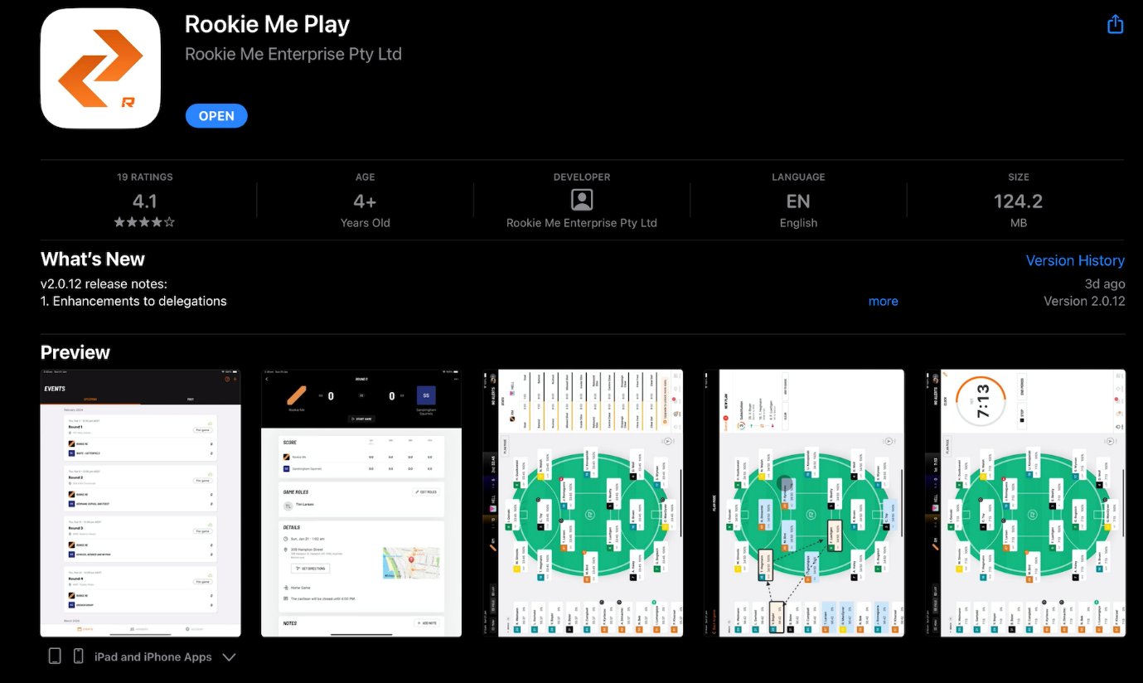
Compatible Devices
iPads & iPhones – see compatible list at end (needs to run minimum IOS 15 and above)
App not currently available for Android devices.

Do I need internet connection?
Yes… and No.
You can operate the app on match day without an internet connection, however you must be connected to the internet the first time you use the app, in order to create your account.

YOU MUST ALSO BE CONNECTED TO WIFI TO DO THE FOLLOWING:
- Create a Team.
- Add a Player to your Team.
- Edit Player details.
- Add an event (game) to your events calendar.
- Edit event details.

App Walk Through
App Walkthrough - Rookie Me Play

Members
Adding Players
- Adding Players Navigate to 'Members' in the navigation bar at the bottom of the screen and select the 'Players' tab.
- Select the plus symbol (+) in the top right hand corner of the page
- Enter in the First Name and Last Name of the player into the designated fields.
- Once you have entered the above, you can select the 'Auto-fill' option in the Display Name field, which will use the initial of their first name and their full last name. Alternatively, you can enter in the display name as desired.
- Enter in the player number.
- If a player with the number you have entered already exists, you will receive a message in red advising a player with the same number already exists ,with the option to change it.
- Once completed, click 'Save', which will take you back to the 'Players' screen.
- Alternatively, you can select 'Save and add another', which will complete your entry and re-populate the form ready for another player to be entered.
- Repeat the process until all desired players are added, then click 'Save' to finalise your new players

Deleting Players
Navigate to 'Members' in the navigation bar at the bottom of the screen and select the 'Players' tab.
- Select the player you wish to remove from the list of available players.
- Select 'Delete' to remove the player.
- A dialog will appear ensuring deletion is the desired action. Select 'Delete' if you wish to proceed, or cancel to stop the action.

CREATING AN EVENT
- Navigate to the 'Events' tab and select the 'Upcoming' tab.
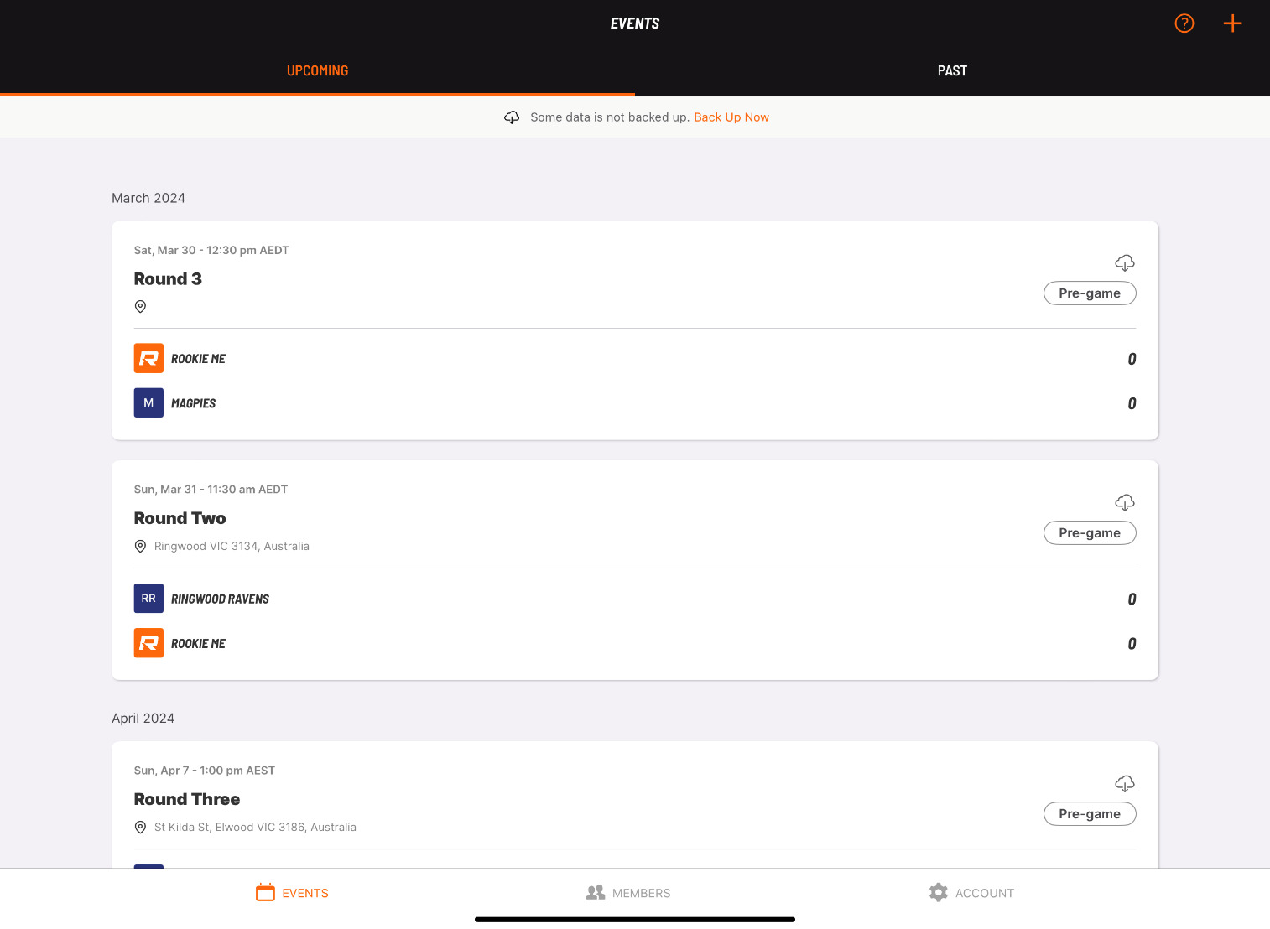
- Select the plus symbol (+) in the top right hand corner of the page to create a new event.
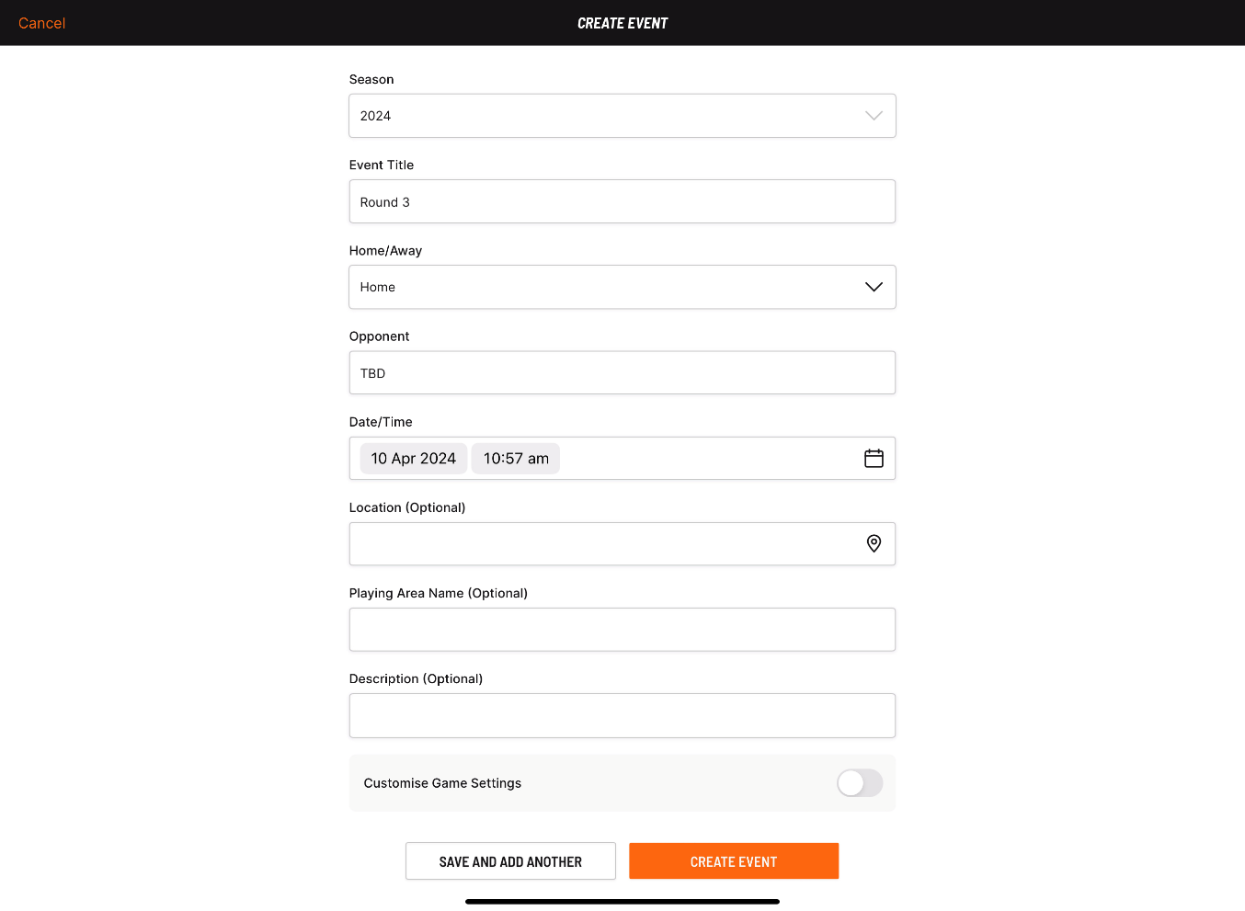
- Enter in the relevant details.
- 'Season', 'Event Title' and 'Opponent' are all mandatory fields, therefore must be entered to be able to create an event.
- All games will default to 'Home' unless you select 'Away'.
- 'Date/Time' can be set for future games, however will default to the current time when creating an event.
- 'Location', 'Playing Area Name' and 'Description' are all optional.
- You can adjust the game settings by toggling the 'Customise Game Settings' on.
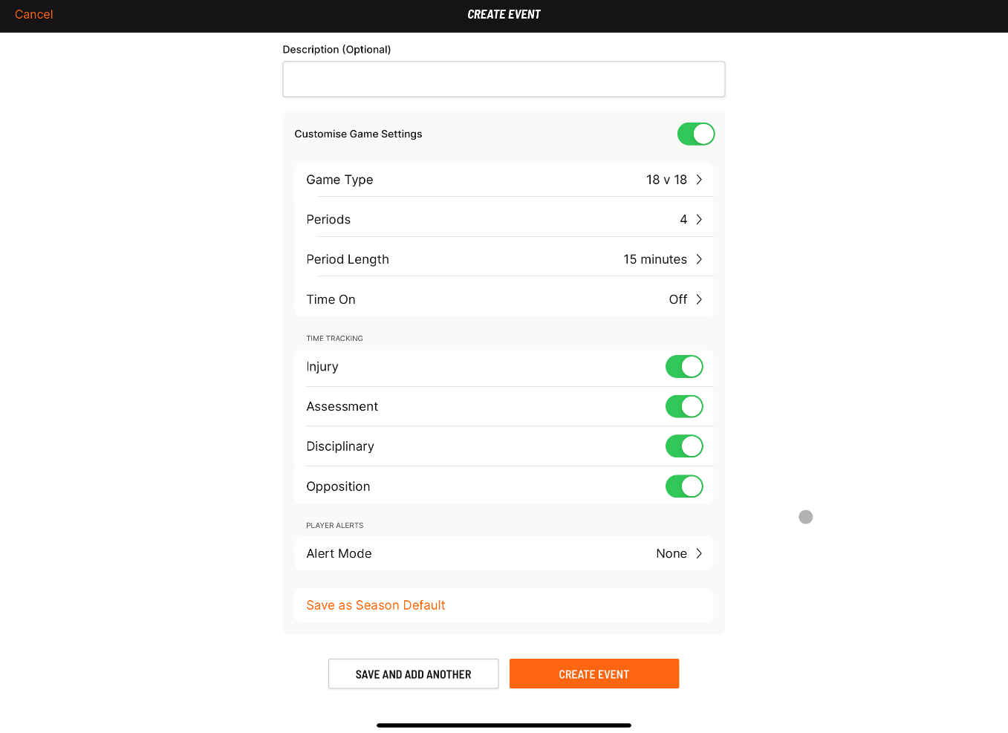
- Edit/update each setting as required.
- Once all details have been entered, select 'Create Event'. Note: you won't be able to create an event unless all mandatory fields have been completed.
- Alternatively, you can select 'Save and add another' and the form will re-populate for you to enter another event.
- Once all events have been entered, you can view your events in the 'Upcoming' tab on the 'Events' page.

Game Settings
Game settings are set up when creating an event. See the following article for creating a new event:
Game Type allows you to configure how many players you will have on the field.
Year 3 and Y3/4 Girls – 12 players
Years 4-10 – 15 players
Y11/12 – 18 players
Periods - 4
Period Length refers to the length of each period for your game
Years 3-6
4x 15-minute quarters - Breaks are 3 minutes, 8 minutes and 3 minutes
Years 7-8, Girls 9/10, Girls 11/12
4x 15-minute quarters - Breaks are 5 minutes, 10 minutes and 5 minutes
Years 9 - 12 Male
4x 20-minute quarters - Breaks are 5 minutes, 10 minutes and 5 minutes

Player Selection
Once you select “Start Game” you will be directed to select the players
- All players will be automatically selected (orange circle with a white tick next to the players name).
- Deselect or select players as necessary by clicking on the orange circle. Deselected players will have a white circle next to their name.
- Use the top menu bar of the player list to organise the list as required
- You can edit any players by selecting the pen icon next to each player and editing their profile as required.
- Once the players have been selected, click 'Continue'.
- You will be directed to set the lineup for the game.
- You can change the set up of the field to either 6-6-6 Traditional or 6-6-6 Stacked Midfield. Change this by selecting the menu option in the bottom left corner.
- You can fill each position manually by selecting and dragging each player to the relevant position.
- Select 'Auto-fill' to have all positions automatically set.
- You can make any changes as required:
  - Dragging a player on the field to another position. This will swap the player positions.
  - Dragging a player from the bench to the field. This will swap the player positions.
- You can select 'Refresh' at the bottom of the screen to change the player positions automatically.
- Once complete, select 'Start Game'.
Can I add players after a game has started?
- Yes, players who are on your team list (but not in your original starting line up) can be added by using the menu function in the top left hand corner of the game screen (list view and field view).
- Additions can be made pre-match and in-match.
- Navigate to the Menu option in the top left hand corner of the screen and select 'Members'
- After selecting 'Members,' a pop-up will appear with both 'Active' and 'Absent' players listed. Players who have been selected to participate will be under the 'Active' heading.
- Select the 'Absent' option to choose from players not originally selected to play.
- Select 'Move to Bench' and the player will appear on your game screen.
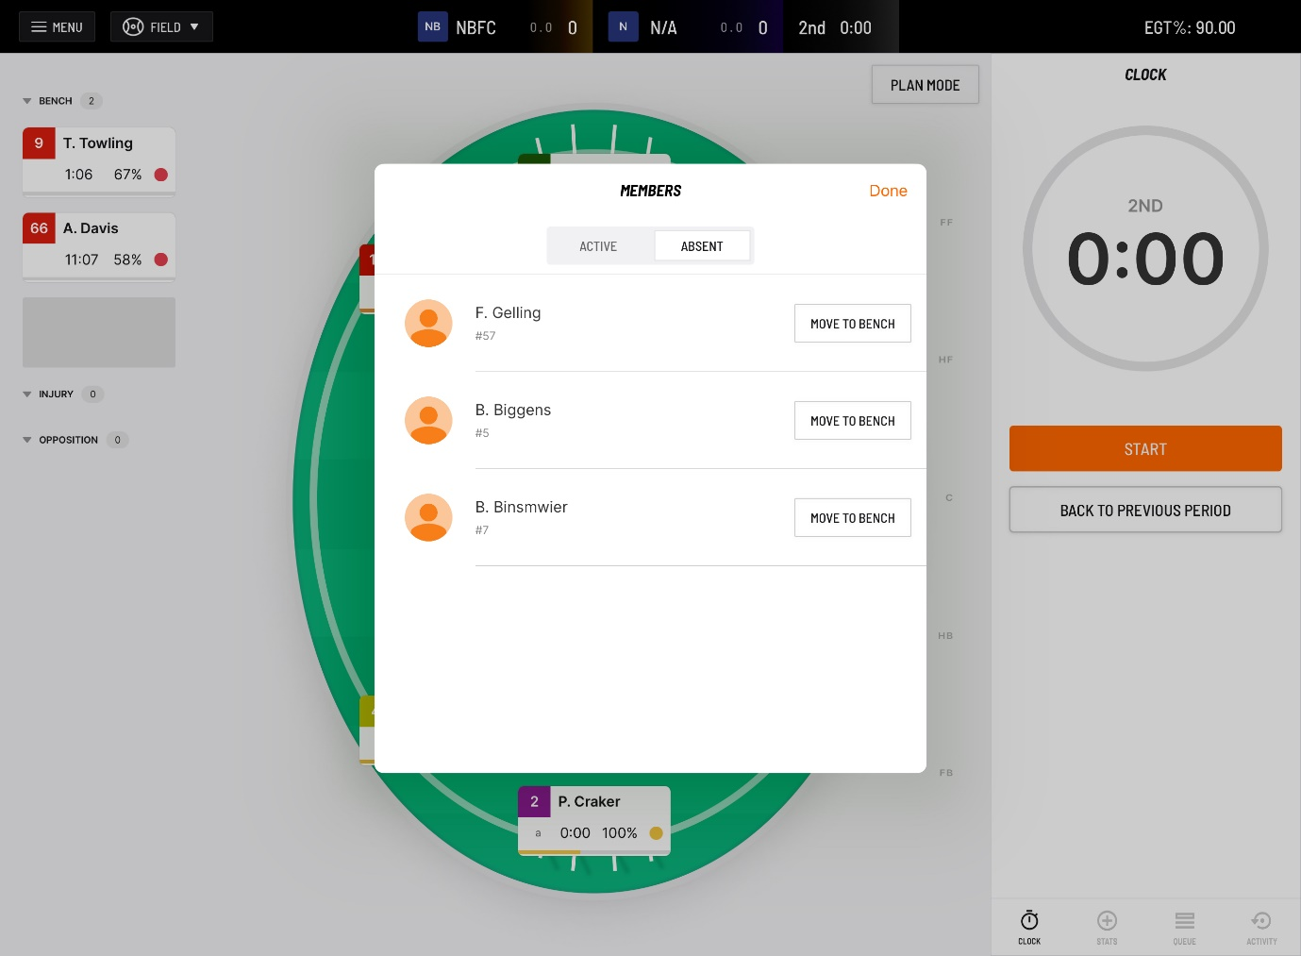

Can I add players to my team just before a game (after I have selected my team)?
Yes, you add players via the menu bar in the top left hand corner.
Can I edit game stats post match?
No, game stats cannot be changed once a game has ended. The last chance to make any alterations or additions is when finalising the last quarter. Once 'End Game' is selected, everything is final.
Do I need to upload the game?
When connected to the internet, your data is uploaded automatically - you are not required to perform an action to save your game to the cloud service.
If you have used the app 'offline,' your data will sync with the server when you next connect to Wi-Fi.

How do I move a player?
There are 4 ways to move a player:

FIELD VIEW FROM THE MAIN SCREEN
Steps:
- Press.
- Drag.
- Drop.

FIELD VIEW FROM PLAYER PROFILE
Steps:
- Move button.
- Tap dropdown menu.

LIST VIEW FROM MAIN SCREEN
Steps:
- Player check box.
- "Time Bucket" you would like the player to move to (e.g. injury).

LIST VIEW FROM PLAYER PROFILE
Steps:
- Move Button.
- Tap dropdown menu.
Percentage Game Time
Percentage Game Time (PGT) = Time on Field / Total Available Time x 100
Time spent in these "time buckets" will not contribute to a players PGT:
- Injury.
- Assessment.
- Disciplinary.
- Absent from the game.
In a 100 minute game a player is recorded as having the following time allocations:
- 10 minutes injured.
- 20 minutes on the bench.
- 70 minutes on-field.

- This player's PGT will be 70/90 = 77% (not 70%).

Time spent in the "opposition time bucket" will count towards a player's PGT.
In a 100 minute game a player is recorded as having the following time allocations:
- 10 minutes "opposition".
- 20 minutes "on the bench".
- 70 minutes on field.
This player's PGT will be 80/100 - 80% (not 70%).

For more information about Rookie Me you can follow the below link:
Rookie Me Play

The following list is collated by Apple and contains all of the devices which should be compatable with iPadOS 15 and, in turn, compatible with the Play app.
- iPad Pro 12.9inch (1st through 6th generations).
- iPad Pro 11inch (1st through 4th generations).
- iPad Pro 10.5inch.
- iPad Pro 9.7inch.
- iPad Air (3rd through 5th generations).
- iPad Air 2.
- iPad mini (4th through 6th generations).
- iPad (5th through 9th generations).
The following list is collated by Apple and contains all of the devices which should be compatable with iOS 15, and in turn, compatiable with the Play app.
- iPhone 14.
- iPhone 14 Plus.
- iPhone 14 Pro.
- iPhone 14 Pro Max.
- iPhone SE (3rd generation).
- iPhone 13.
- iPhone 13 mini.
- iPhone 13 Pro.
- iPhone 13 Pro Max.
- iPhone 12.
- iPhone 12 mini.
- iPhone 12 Pro.
- iPhone 12 Pro Max.
- iPhone SE (2nd generation)
- iPhone 11.
- iPhone 11 Pro.
- iPhone 11 Pro Max.
- iPhone X.
- iPhone XR.
- iPhone XS.
- iPhone XS Max.
- iPhone 8.
- iPhone 8 Plus.
- iPhone 7.
- iPhone 7 Plus.
- iPhone SE (1st generation)
- iPhone 6s.
- iPhone 6s Plus.

