

**PK Recruitment Athlete Presentation**

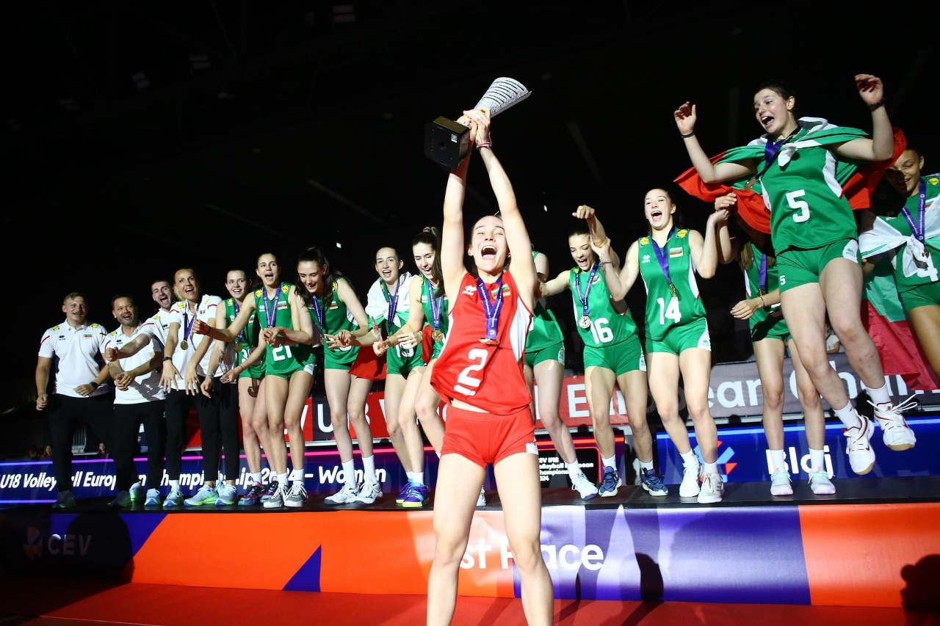

**Personal Information**

Name: *Viktoria Ninova*

Sport: *Volleyball*

Date of Birth: *09.11.2007*

Gender: *Female*

Club Team: *CSKA Sofia*

**Athletic Background**

When did you start practicing your sport? *7 years ago*

Position: *Libero*

Height: *5’7*

Weight: *59 kg.*

Reach: -

Standing High Jump: -

Approach High Jump: *-*

**Education**

High School Name: *High School 22 Georgi S. Rakovski*

Graduation Date: *May, 2026*

Languages: *English, Bulgarian*

Desired Degree (Major and Minor): *Undeclared*

SAT / TOEFL / IELTS / Duolingo Grades and Dates: *Duolingo: 125 points*

**Athletic Achievements**

**Achievements:**

*Best libero award season 2021/2022 – National Championship*

*Best hitter award season 2021/2022 – National Championship*

*Best libero award season 2022/2023 – National Championship*

*Best libero award season 2023/2024 – National Championship*

*Best libero award season 2023/2024 – Balkan Championship*

*Best libero award season 2024/2025 – National Championship*

**List of participation in athletic events:**

*2nd place-girls u16-National Championship(season 2021/2022)*

*2nd place-girls u18-National Championship(season 2021/2022)*

*3rd place-girls u18- National Championship (season 2022/2023)*

*2nd place-girls u20- National Championship (season 2022/2023)*

*2nd place-women-Demax League(season 2022/2023)*

*3rd place-Balkan Championship girls u17(season 2022/2023)*

*8th place-World Championship girls u19(season 2022/2023)*

*2nd place – women – Demax League (season 2023/2024)*

*2nd place – girls u19 – National Championship (season 2023/2024)*

*2nd place – Balkan Championship girls u18(season 2023/2024)*

*1st place – European Championship u18 (season 2023/2024)*

*3rd place – women - Demax League (season 2024/2025)*

**Media**

**Photos:**

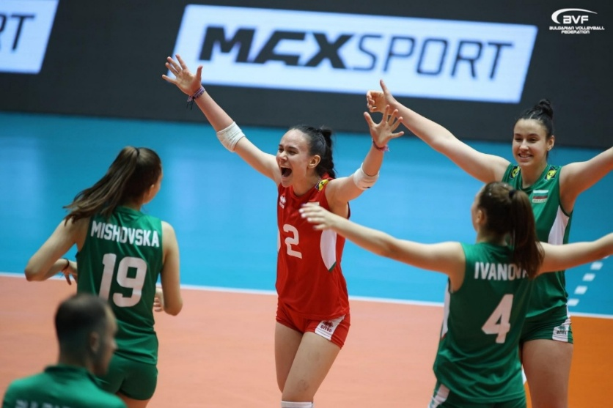

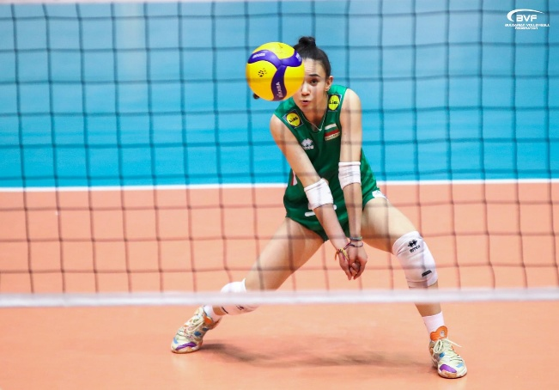

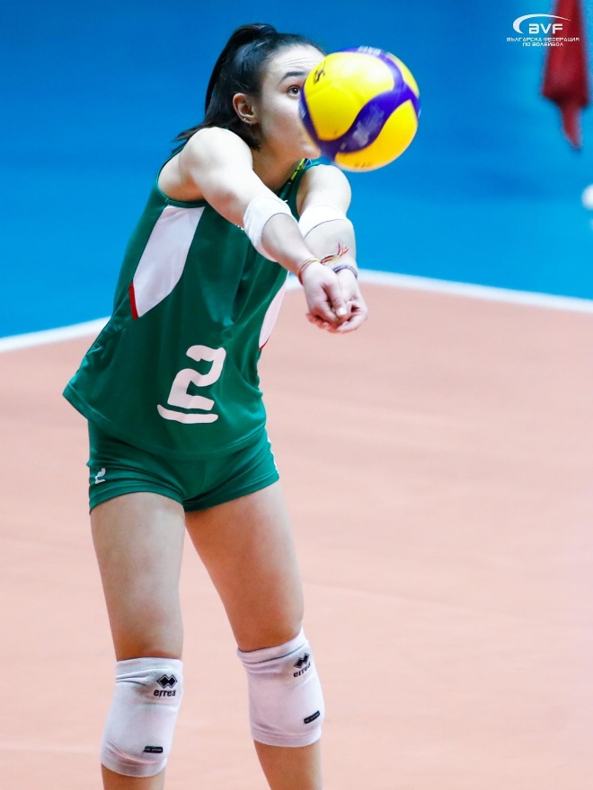

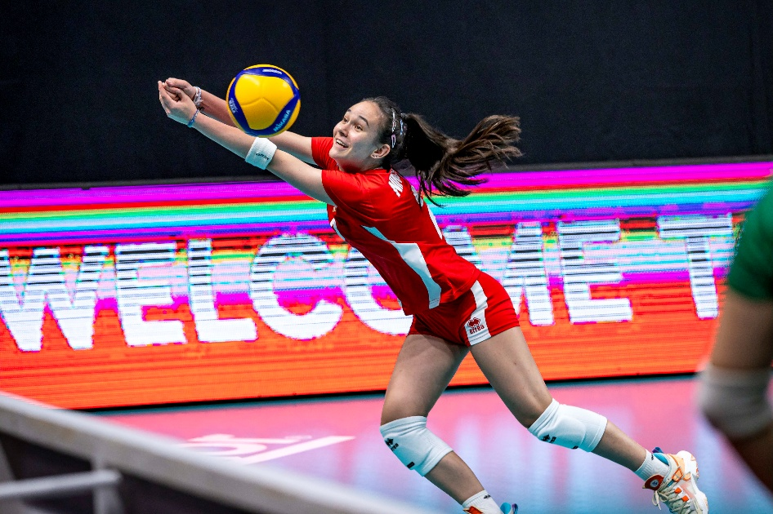

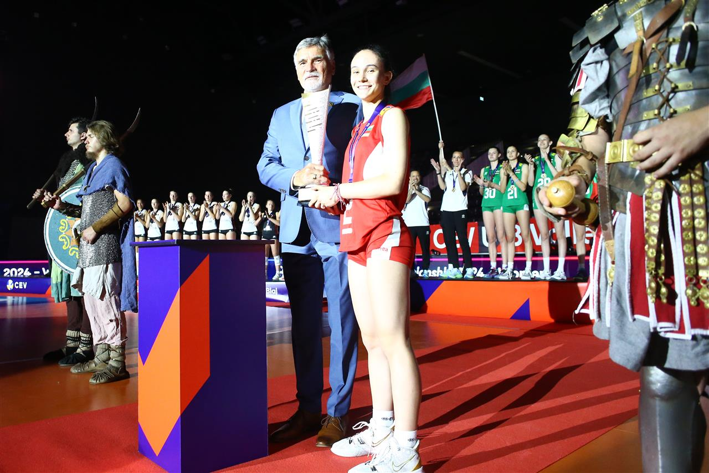

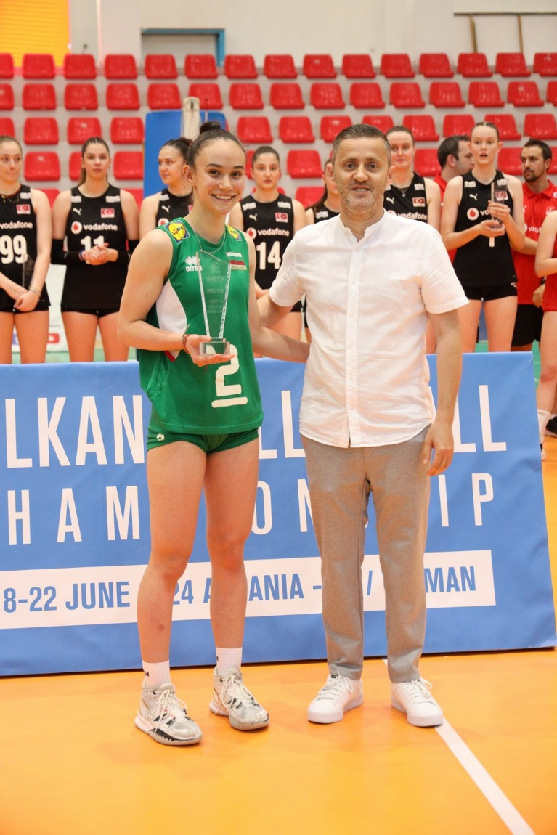

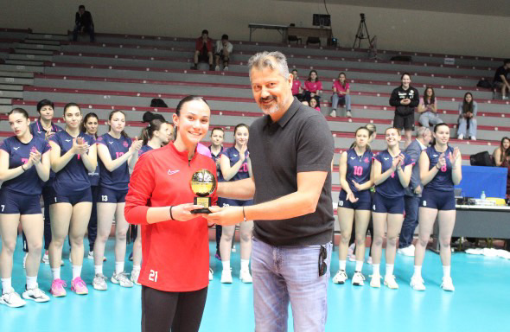

**Videos:**

* 1. Highlight Video

[*https://youtu.be/MlIcgR1Owpg?si=quZ324mgw0eC7S78*](https://youtu.be/MlIcgR1Owpg?si=quZ324mgw0eC7S78)

* 1. Тwo Full Matches

[*https://www.youtube.com/live/07xFtVG2zU0?si=hpLQTl0B3jVOgiGH*](https://www.youtube.com/live/07xFtVG2zU0?si=hpLQTl0B3jVOgiGH)

[*https://www.youtube.com/live/HlXaXWQSYRs?si=sjwmFwb2FE1xShj8*](https://www.youtube.com/live/HlXaXWQSYRs?si=sjwmFwb2FE1xShj8)

**Interview Questions**

**Describe yourself with a few sentences:**

*I am a person who never gives up, no matter how many ups and downs I face. I always stay focused on my goals and push through every challenge. I easily connect with people, accept criticism, and constantly give my best effort during practices and matches.*

**What does sport mean to you?**

*Volleyball is a huge part of my life. It has shaped my character, taught me discipline, teamwork, and how to stay strong in tough situations. It motivates me to constantly work hard, improve, and chase my dreams both on and off the court.*

**What does your education mean to you?**

*Education is very important to me because it opens doors to opportunities and helps me grow not only professionally, but also personally. I see education as a tool that will prepare me for life after sports and help me achieve stability and success in the future.*

**What are your main goals as a student-athlete in the USA?**

*My main goals as a student-athlete are to combine both academics and sports at a high level. I want to achieve strong results both on the court and in the classroom, and to build relationships with people from all over the world who share similar ambitions. Competing in college will give me the perfect environment to grow, improve, and reach my full potential.*

**Documentation**

Translated Official Transcripts from 8th Grade until Present

-